**TARUN**

**(CONNECTING PEOPLE WITH PURPOSE)**

PROF. BLESSING

RIAZ AHMED

NUSRAT RIAZ

# Revisions Page

|  |  |  |  |  |
| --- | --- | --- | --- | --- |
| **Serial No.** | **Document Version** | **Revision Date** | **Revision Description** | **Revised By** |
| 1 | 1.0 | 27/03/2019 | Basic document template added | Prof. Blessing |
| 4 | 2.2 | 17/12/2018 | System components and diagrams have been worked on | Prof. Blessing |
| 5 | 2.3 | 19/12/2018 | System architecture explained | Prof. Blessing |
| 6 | 3.0 | 27/03/2019 | Test section added | Prof. Blessing, Riaz, Nusrat |
| 7 | 4.0 | 27/03/2019 | User manual and conclusions added | Prof. Blessing, Riaz, Nusrat |

Table of Contents

Revisions Page 2

1 Introduction 4

1.1 Design Overview 4

1.1.1 Current System: 4

1.1.2 Proposed system: 4

1.2 Requirements Traceability Matrix 4

2 System Architectural Design…………………………………………………………………………..5

2.1 Final System Architecture…………………………………………………………………………5

3. Data Design…………………………………………………………………………………………….6.

3.1 Database Diagram (including fields details)…………………………………………………….6

4 Detailed Description of Components……………………………………………………………9

5 User Interface Design……………………………………………………………………………9

5.1 Description of the User Interface 9

5.1.1 Screen Images 9

5.1.2 Screen Objects and Actions………………………………………………………………10.

6 Security………………………………………………………………………………………………….14

6.1 **User Level Permissions**……………………………………………………………………14

6.2 **Control Points……………………………………………………………………………..14**

**7 Testing………………………………………………………………………………………….14**

8 User Manual ……. ….14

9 Conclusions and Recommendations ..15

# 1 Introduction

## 1.1 Design Overview

Tarun is an organization set up to connect people in a community with available services. This application is designed to use a computerized system to connect people in a community. The scope includes:

Setting up the development environment

Design User Interface (UI) views

Database design

Creating queries for data manipulation

Testing and debugging

Acceptance Testing

### 1.1.1 Current System:

* Manual system in operation (not automated or computerized)

### 1.1.2 Proposed system:

* Proposed system will automatically help to connect people in the same community to available service which was being done manually.

## 1.2 [Requirements Traceability Matrix](https://docs.google.com/spreadsheets/d/1A0uNKK0jot5kEOXBi7GSMryVnO-v035IzjH2jgf8mEk/edit?usp=sharing)

|  |  |  |  |  |  |  |  |  |
| --- | --- | --- | --- | --- | --- | --- | --- | --- |
| **Requirement Id** | **Technical Assumptions** | **Functional Requirement** | **Description** | **System Component** | **Status** | **Accepted By** | **Tested By** | **Priority** |
| **1.0** | Database  Recipients Table  Servers Table  Service available table | Software Requirement | People who will register to get the service.  Services offering(one who provides the service).  List of available service | Table | Completed | ProfBleNUS  RIA | NUS  RIA | High |
| **2.0** | Log in Information | FunctionalRequirement | Creation of Account name and password for users to be able to log into the database | Table | Completed | ProfBle  NUS  RIA | NUS  RIA | Medium |
| **2.1** | Service Available | Business Requirement | List of available services in drop down list | Table | Completed | ProfBle  NUS  RIA | NUS  RIA | Medium |
| **2.2** | Request received | Business Requirement | Type of services requested, location, and option box | Table | Completed | ProfBle  NUS  RIA | NUS  RIA | Medium |
| **3.0** | System admin features | Business Requirement | To generate reports:  Custom report creation | Table | Completed | ProfBle  NUS  RIA | NUS  RIA | High |
| **3.1** | Registration Screen | Business Requirement | Individuals are invited to register themselves for either as recipient or service provider. | Table | Completed | ProfBle  NUS  RIA | NUS  RIA | Medium |
| **3.1.1** | Request screen | Business Requirement | Individuals looking for specific assistance would fill out the request form and submit it. | Table | Completed | ProfBle  NUS  RIA | NUS  RIA | Medium |
| **3.1.2** | Available Services screen | Business Requirement | People would be able to view and register for the available roles of their interest. | Table | Completed | ProfBle  NUS  RIA | NUS  RIA | Medium |

**2 SYSTEM ARCHITECTURAL DESIGN**

**2.1 Final System Architecture**

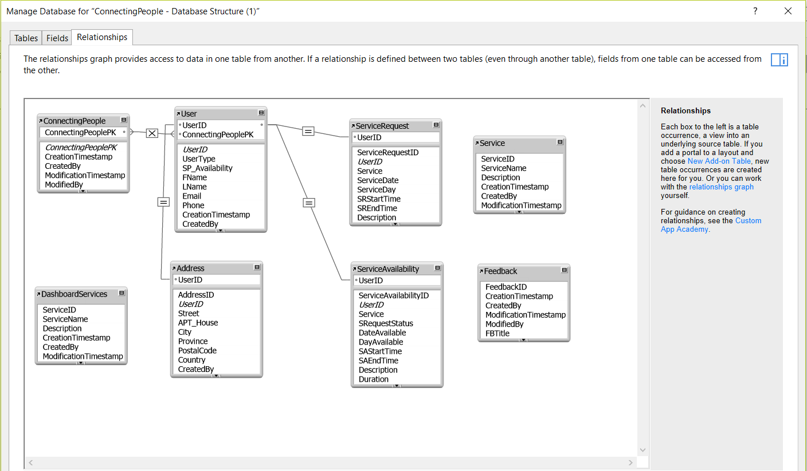

**3 DATA DESIGN**

**3.1 Database Diagram** (include field details)

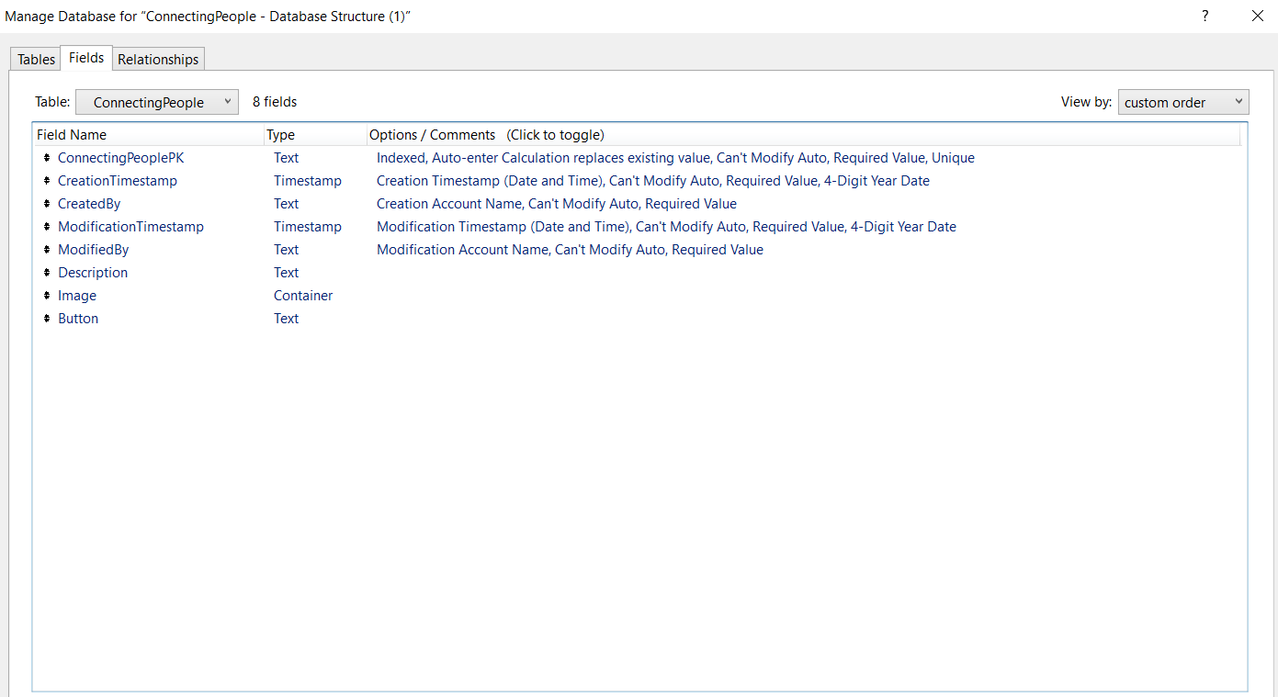

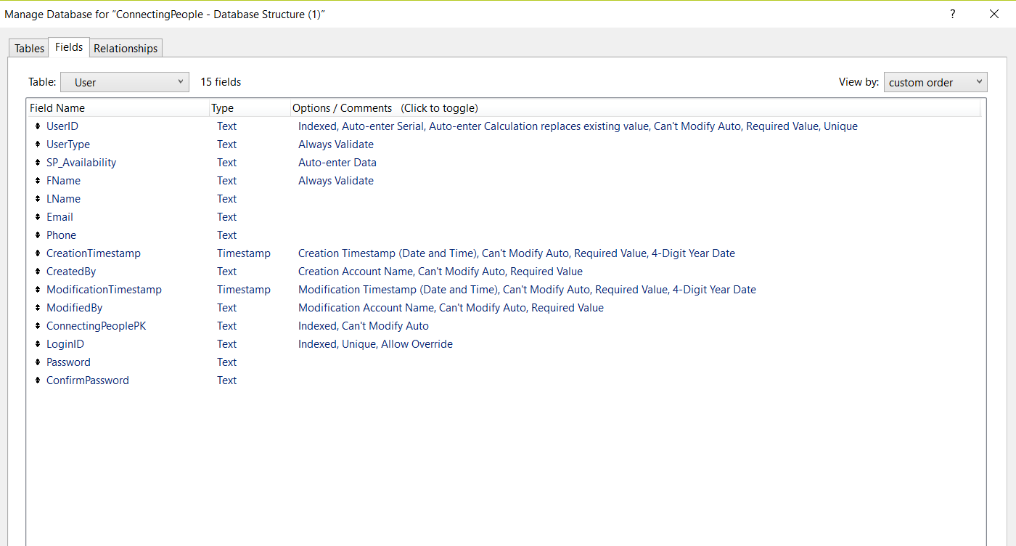

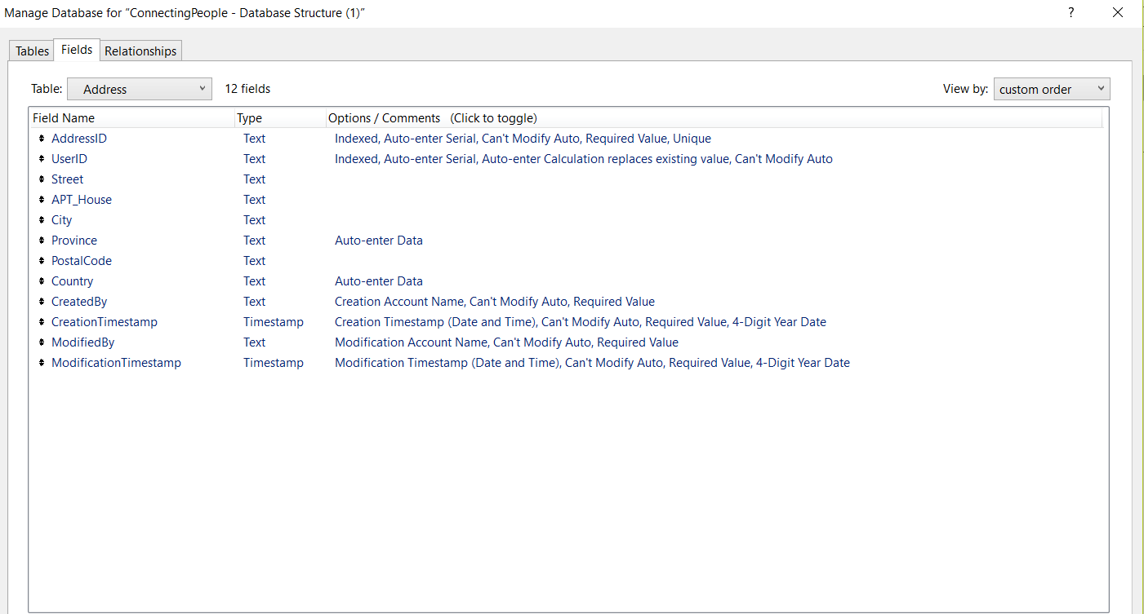

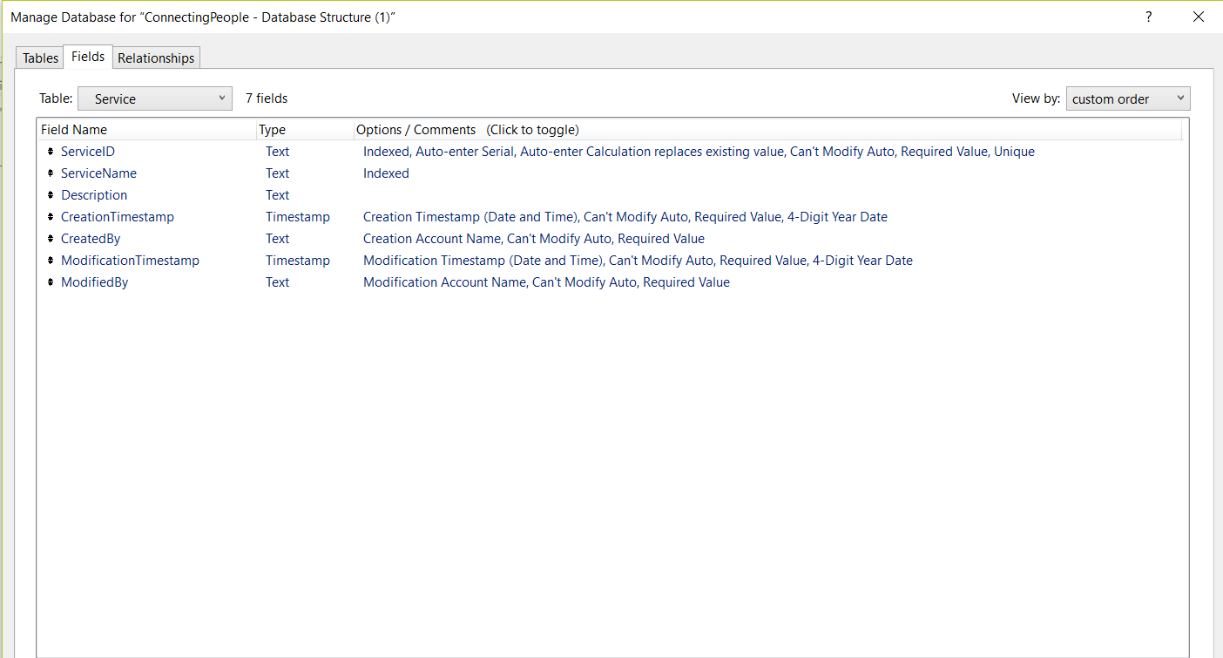

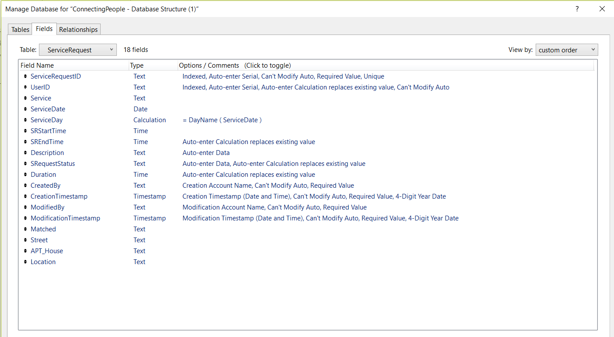

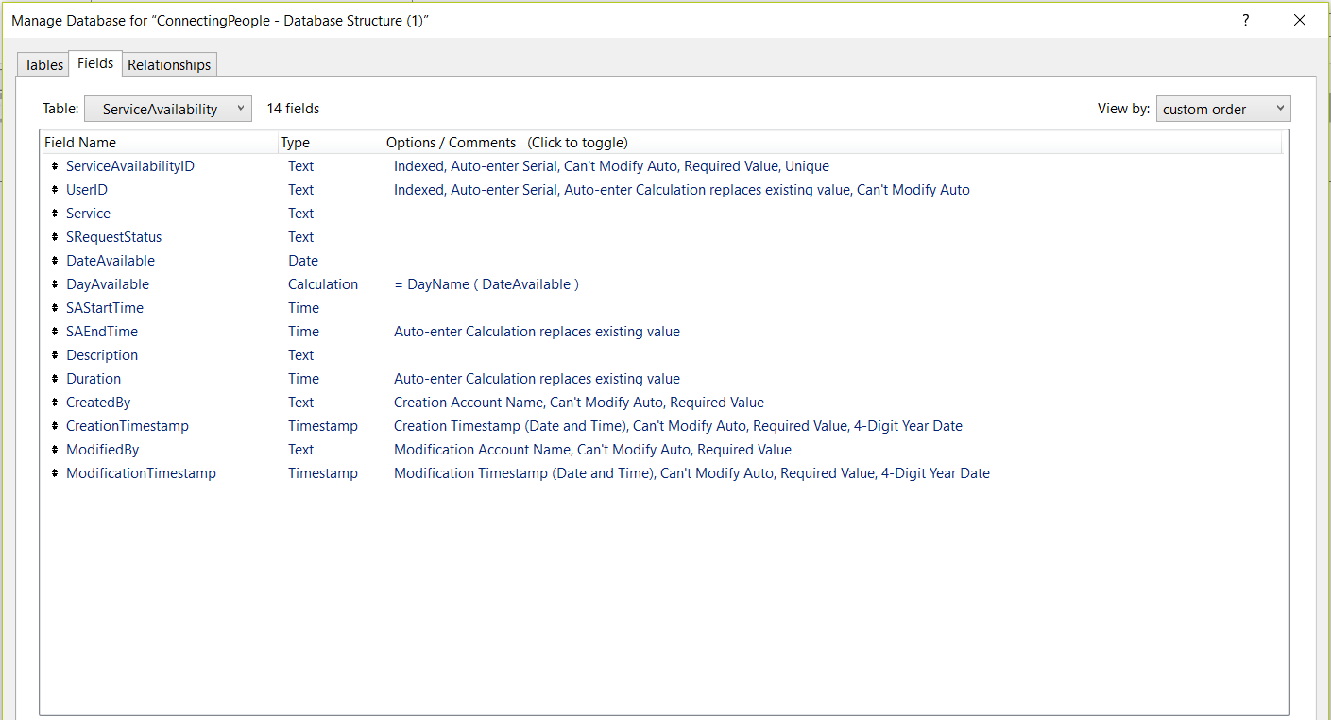

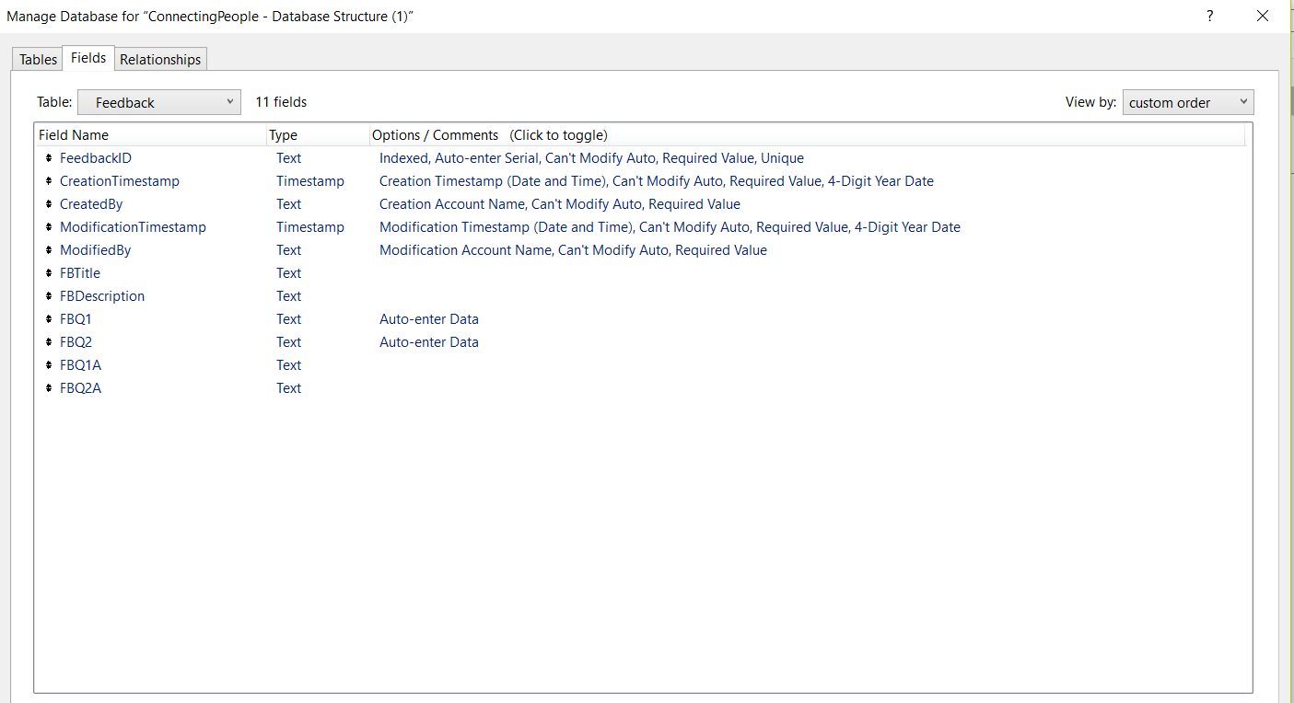

**4 DETAILED DESCRIPTION OF COMPONENTS**

4.1 File maker software was use in developing this application by creating tables.

**5 USER INTERFACE DESIGN**

**5.1 Description of the User Interface**

User will be able to create a profile as a service provider and log into the database to view the available request. Reports are generated based on the profile created and the request and services signed up for. File maker software was use in developing this application by creating tables.

**5.1.1 Screen Images** (Display screenshots showing the interface from the user’s perspective)

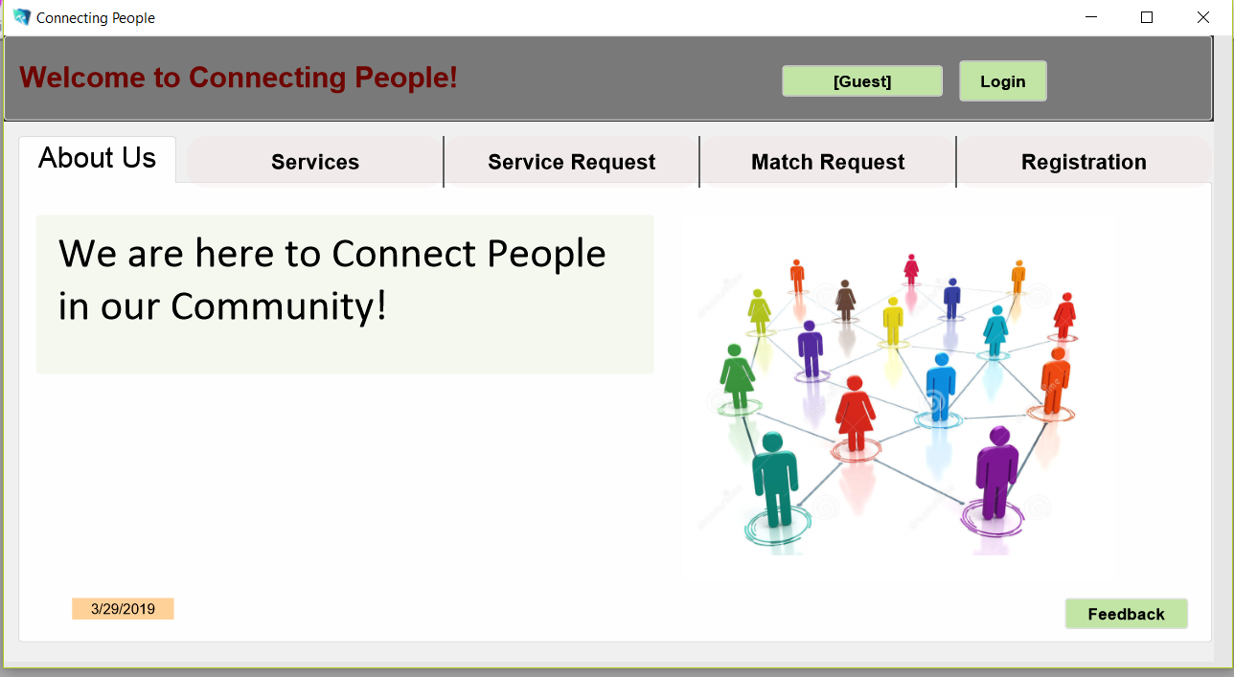

**5.1.2 Screen Objects and Actions**

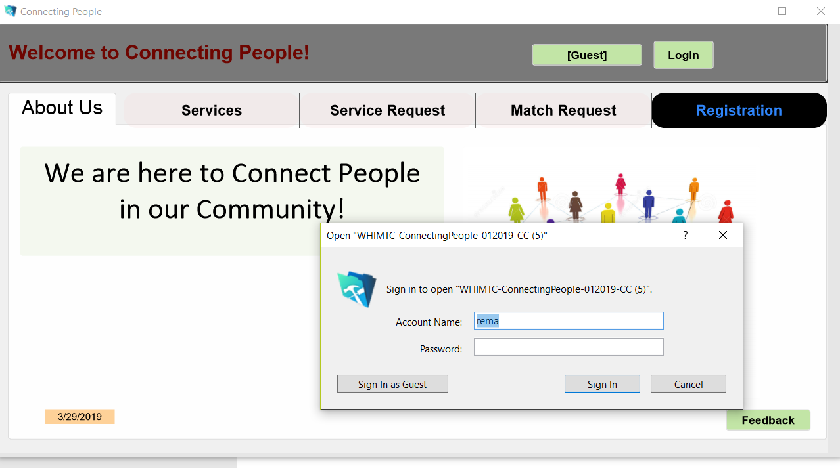

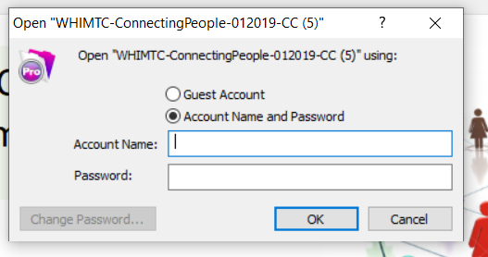

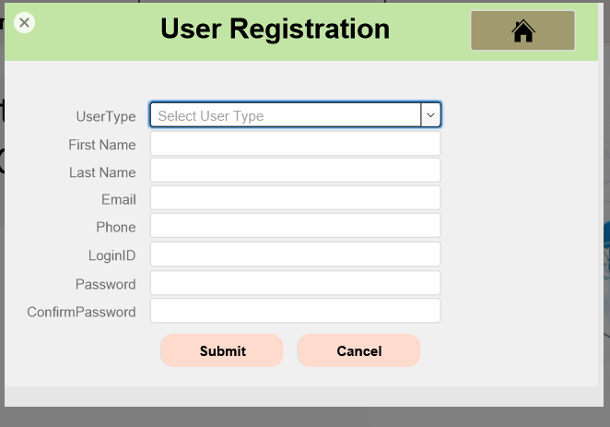

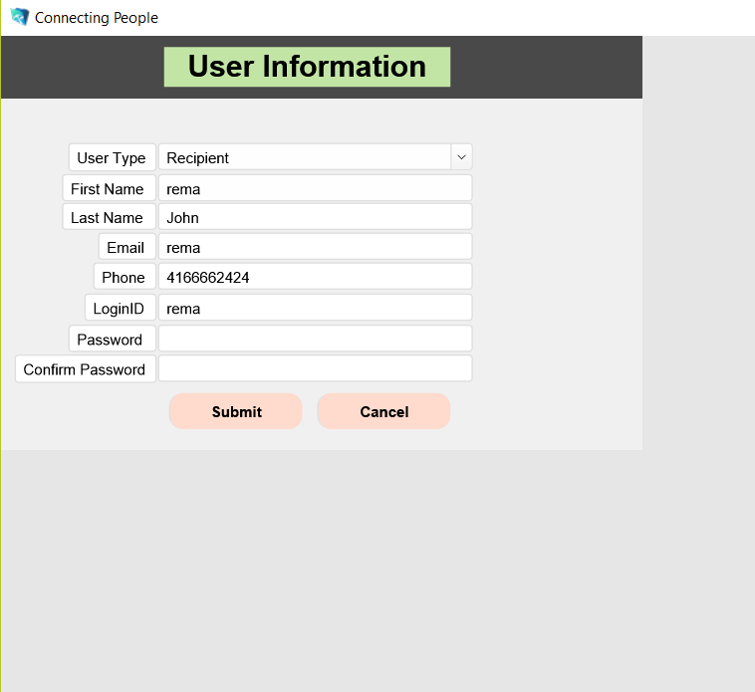

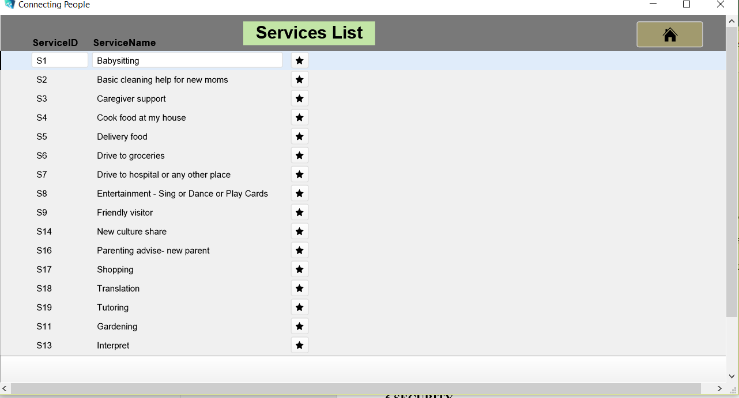

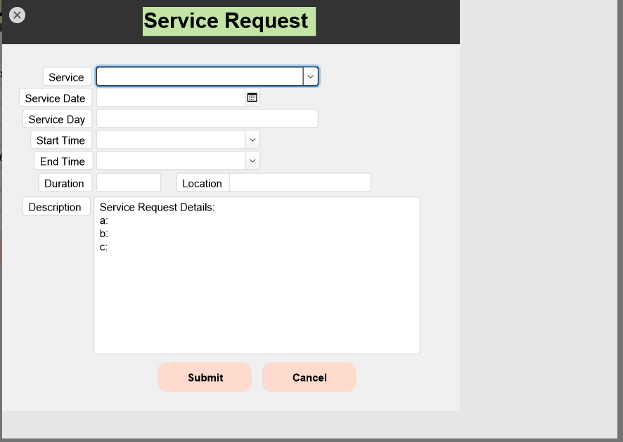

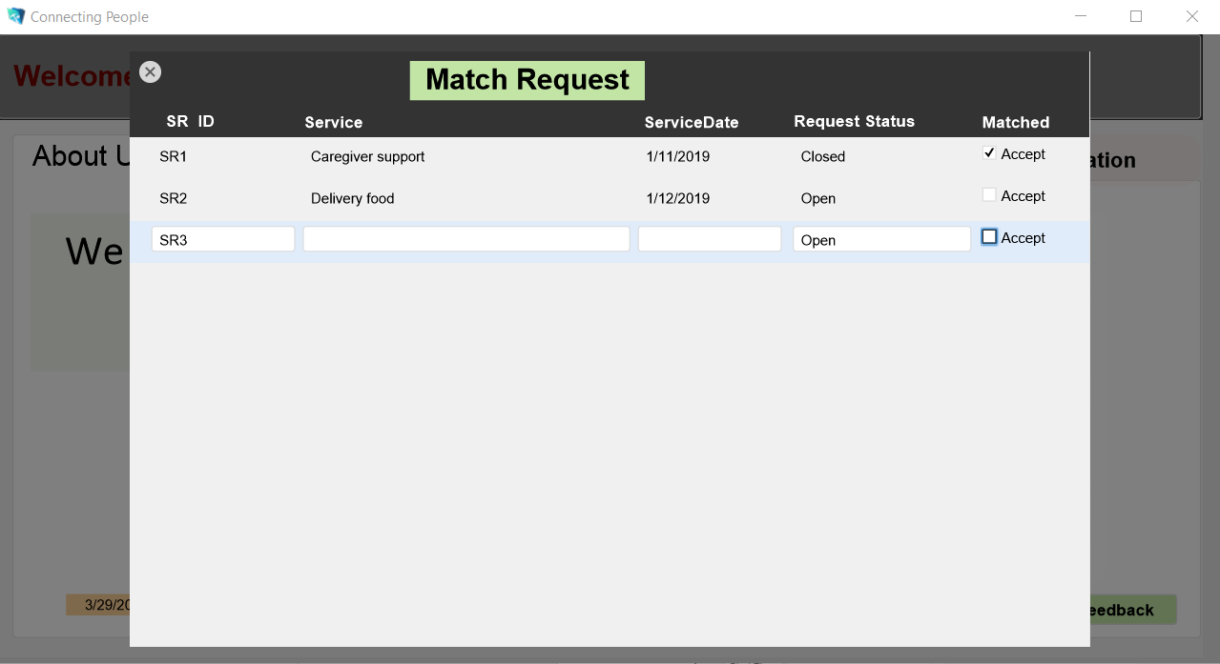

**6 SECURITY**

**6.1 User Level Permissions**

Only registered users can have access to the all the available menus, if you are a guest you have to register before access can be given to you to all the available menus

**6.2 Control Points** (where in the system the security is checked)

**7 Testing**

Tests have been attached to this file



1. **User Manu**al **DETAIL DESCRIPTION OF EACH OF THE MODULE AND SCREEN SHOTS**

On launching the application (3) three tabs with (6) menus/ ribbons are displayed on the screen

**TABS**

GUEST: - To login as a guest

LOGIN: - To login based on existing user

UPDATE PROFILE: - modifying profiles created if changes occurs.

**MENUS/ RIBBONS**

**About Us**

Information about the organization (Tarun)



**Report**

Lists of reports generated for the following:

The user clicks on report menu and can view:

* List of list of registered user

Click on service provider details to see the details if it is accepted, if not accepted it will be blank

**Services**

List of available services



**Service Request**

List of services requested for which the service provider can choose from and then clicks on submit.



**Match Request**

Services that has been matched or accepted and services that are still open. The service provider can then accept the service by clicking on the check box Accept, status changes from open to close



**Registration**

Registration as a new user, recipient or service provider, i.e create an account either as a service provider or as a recipient. Service provider also provides the availability by clicking on availability, then clicks on submit.



Reports:

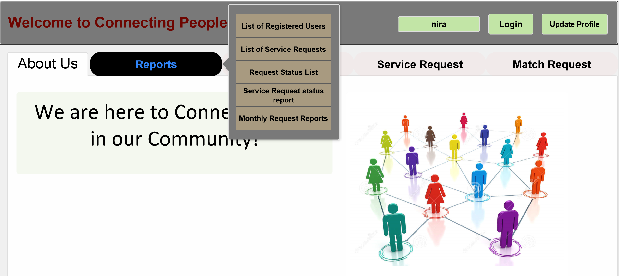

List of Registered Users

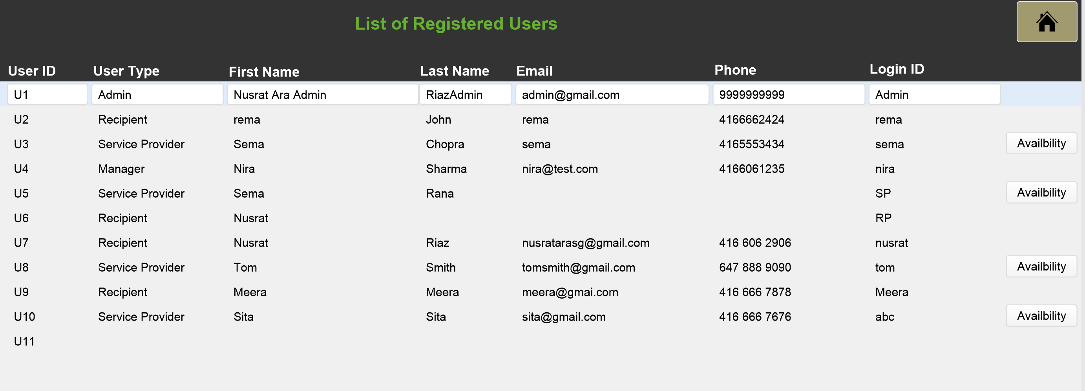

List of Service Requests:

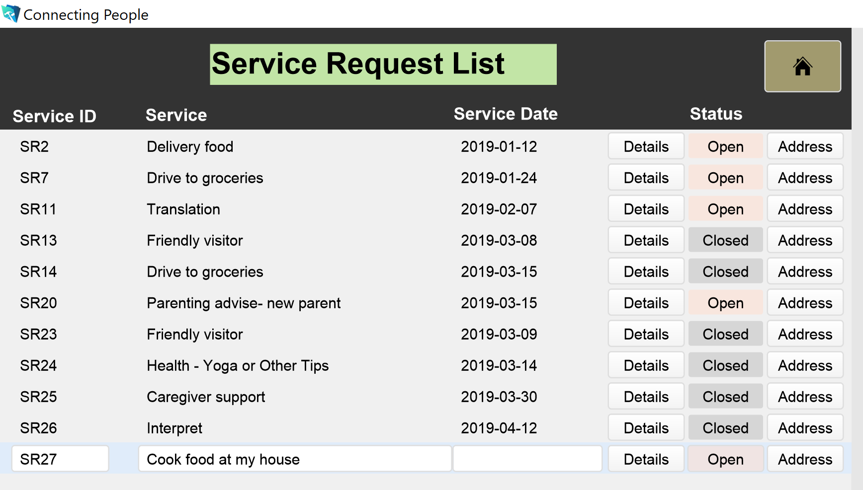

Service Request Status

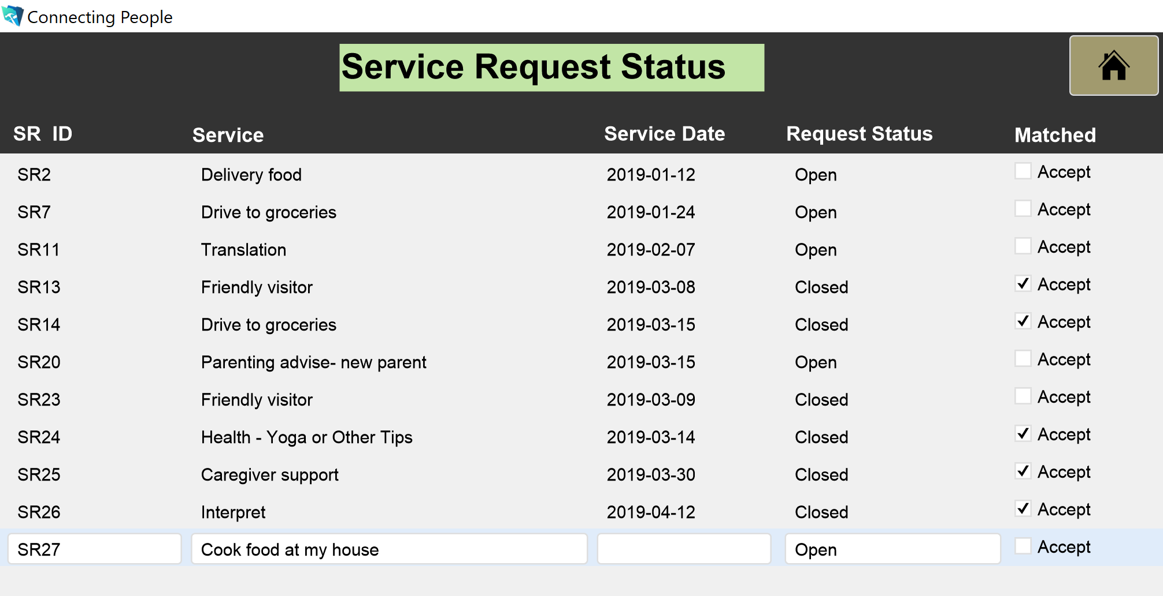

Service Request Status Details:

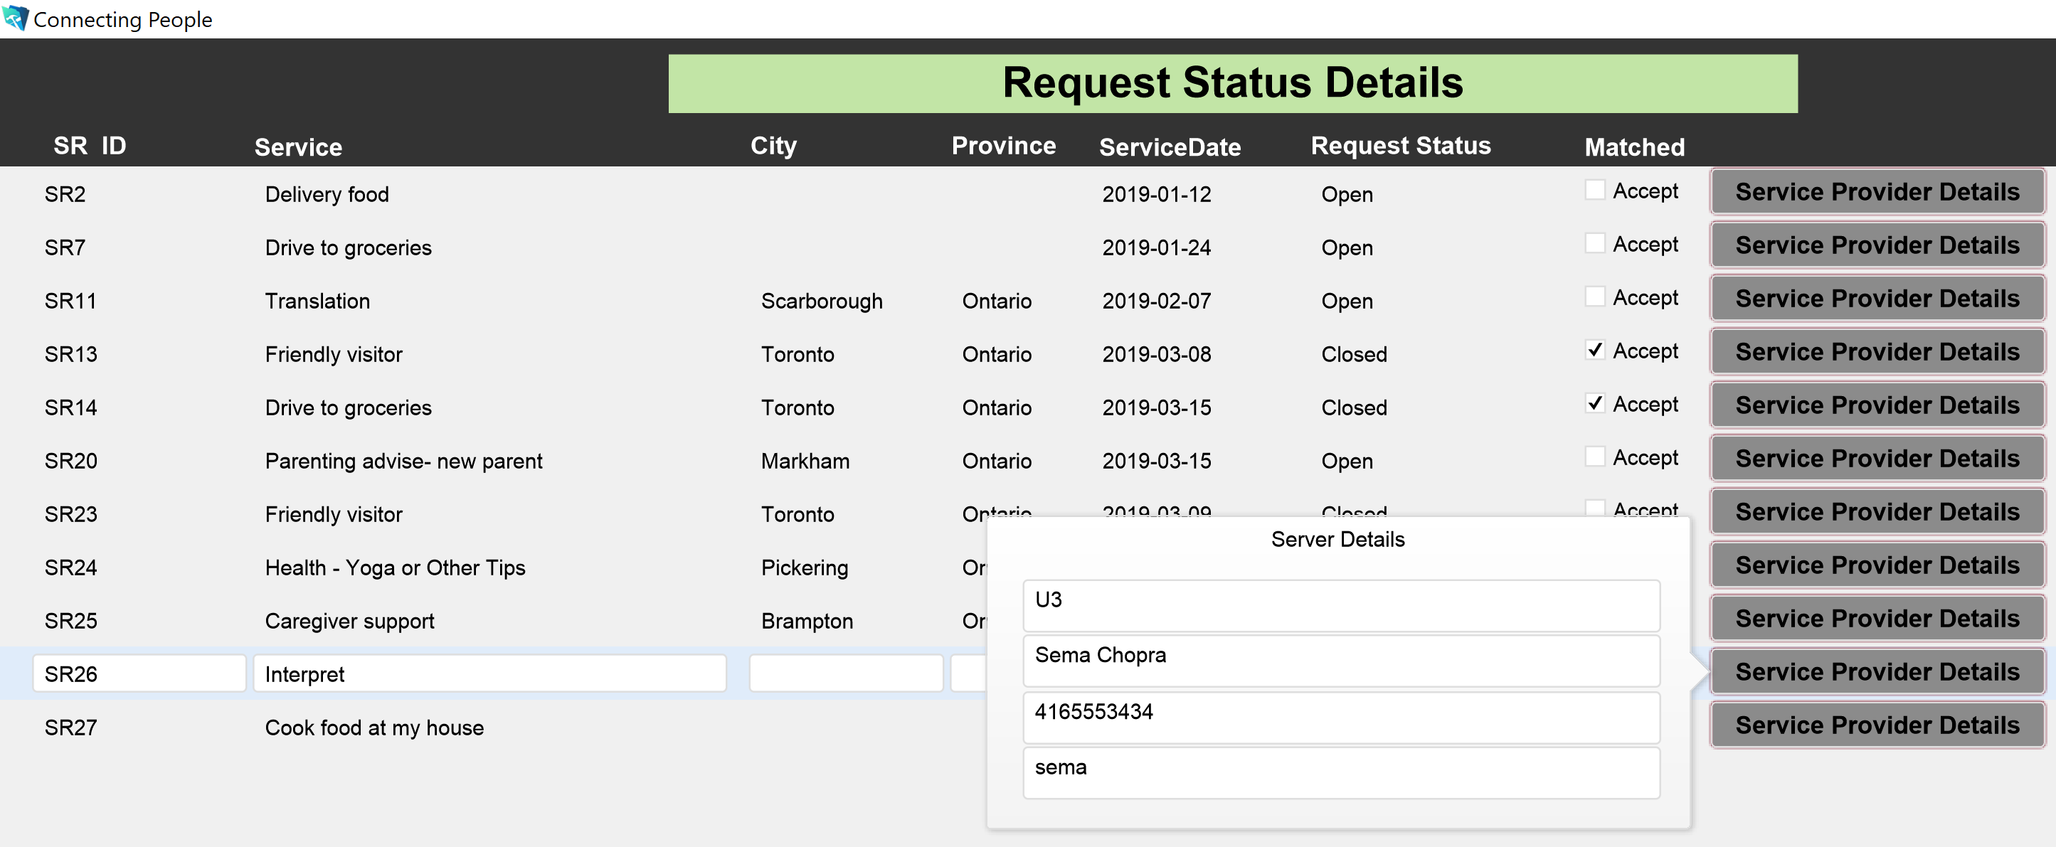

1. **Conclusions and recommendations**

This application has been designed to connect people together in the same community based on the request made and available services.